Standard PPE Requirements For Department

Steel toe cap footwear is required for the department operation, whether these be in the form of boots or shoes, both are acceptable. Please contact you production manager immediately if you do not have the correct footwear. | 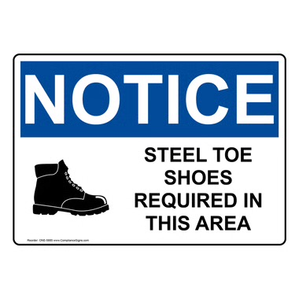
Ear protection is provided at the entrance to the department and is a requirement during production activity times. Please contact your production manager immediately if you require alternative hearing protection. | 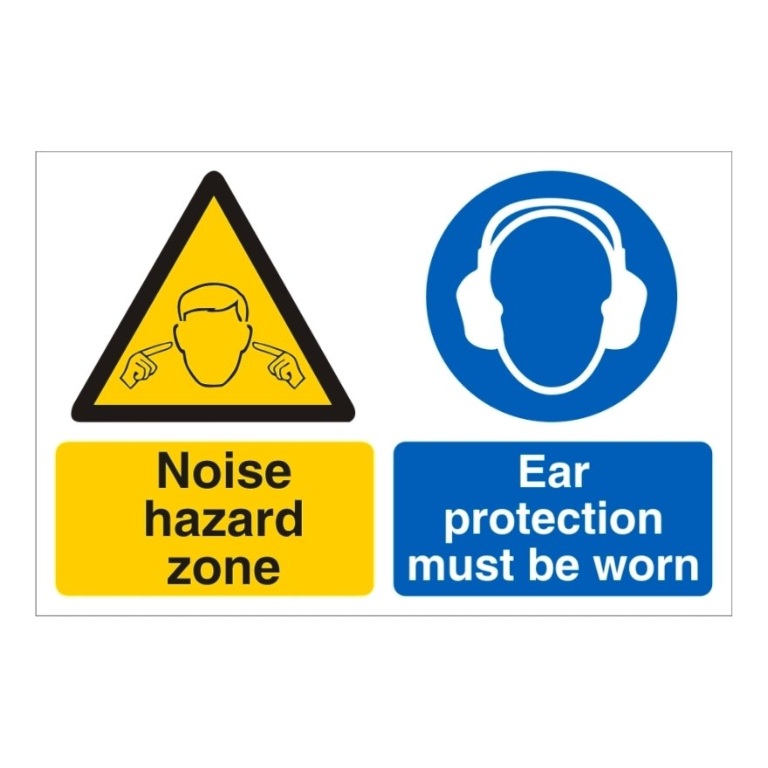

Key Purpose of The Procedure

*Title

